**PRIMARY THREE EXAMS**

**RELIGIOUS EDUCATION MID TERM THREE 2024**

***Time Allowed: 2 Hours***

NAME…………………………………………………………

**SECTION A**

1. **Either:** Who was the earthly father of Jesus?

_____________________________________________________________

**Or:** Who was the father of prophet Muhammad?

_____________________________________________________________

1. **Either:** Name the place where God put Adam and Eve after creation.

_____________________________________________________________

**Or:** Name the garden where Adam and Hawa lived.

_____________________________________________________________

1. **Either:** Write one Christian name for girls.

_____________________________________________________________

**Or:** Write one moslem name for girls.

_____________________________________________________________

1. **Either:** What should a P.3 Christian child do after sinning?

_____________________________________________________________

**Or:** What should a P.3 moslem child do after sinning?

_____________________________________________________________

1. **Either:** State any **one** way Christians worship God.

_____________________________________________________________

**Or:** Mention any one way a moslem worships God.

_____________________________________________________________

1. **Either:** On which day was the last supper?

_____________________________________________________________

**Or:** When do moslems go for Juma prayers?

_____________________________________________________________

1. **Either:** How can a good Christian child care for others?

_____________________________________________________________

**Or:** How can a good moslem child care for others?

_____________________________________________________________

1. **Either:** Draw and name any Christian symbol.



**Or:** Give one way a good moslem cares for others.

_____________________________________________________________

1. **Either:** What name is given to the fasting period for Christians?

_____________________________________________________________

**Or:** Which name is given to the fasting period for moslems?

_____________________________________________________________

1. **Either:** Which apostle denied Jesus?

_____________________________________________________________

**Or:** Name the book that was received by prophet Dauda.

_____________________________________________________________

1. **Either:** Who finally led the Israelites to the promised land?

_____________________________________________________________

**Or:** Name the town where Prophet Muhammad was born.

_____________________________________________________________

1. **Either:** For how long did God take to create the universe?

_____________________________________________________________

**Or:** For how long did Allah take to create the world?

_____________________________________________________________

1. **Both:** What do we call the way of talking to God?

_____________________________________________________________

1. **Either:** How is a pastor useful to the church members?

_____________________________________________________________

**Or:** Write the role of the Imam.

_____________________________________________________________

1. **Either:** On which day did the apostles receive the Holy Spirit?

_____________________________________________________________

**Or:** Who was the last prophet in Islam?

_____________________________________________________________

1. **Both:** Give any one similarity between islam and Christianity.

__________________________________________________________________________________________________________________________

1. **Either:** Write C.R.E in full.

_____________________________________________________________

**Or:** Write I.R.E in full.

_____________________________________________________________

1. **Either:** Who led the people who arrested Jesus where He was?

_____________________________________________________________

**Or:** What is the moslem name for Jesus?

_____________________________________________________________

1. **Either:** Identify any one gift God gave you.

_____________________________________________________________

**Or:** Which gift helps you to write in books?

_____________________________________________________________

**For both**

1. Give any **one** example of a custom.

_____________________________________________________________

**SECTION B**

1. Who said these words **“behold, I will send you a helper”?**

_____________________________________________________________

b) Which helper was promised?

_________________________________________________________

c) Give **two** reasons why Jesus gave us the Holy Spirit.

(i) ___________________________________________________

(ii) ___________________________________________________

**Or:** Mention any four prophets who received holy books in islam.

1. ________________________________________________________
2. ________________________________________________________
3. ________________________________________________________
4. ________________________________________________________
5. **Either:** Match correctly.

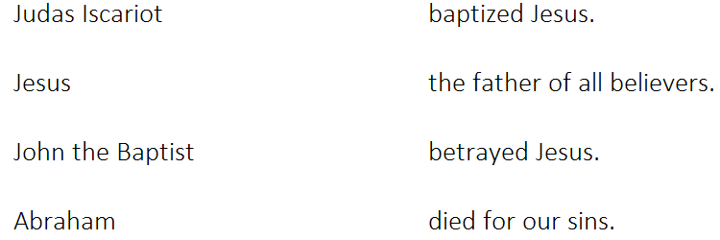

**Or:** Match correctly

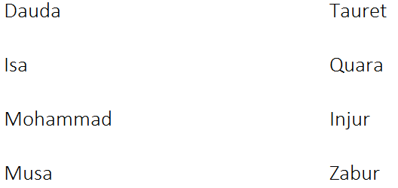

1. **Both:** Draw these creatures God / Allah created.

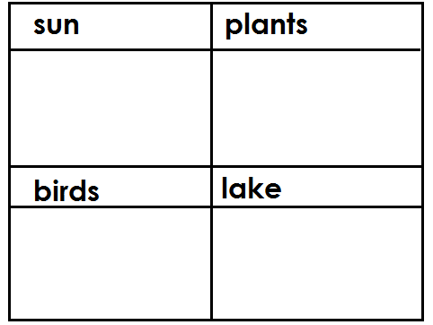

1. **Either:** Mention any **two** fruits of the Holy Spirit.
2. ________________________________________________________
3. ________________________________________________________
4. Give any **two** gifts of the Holy Spirit.
5. ________________________________________________________
6. ________________________________________________________

**Or:** Give **four** impurities in islam.

1. ________________________________________________________
2. ________________________________________________________
3. ________________________________________________________
4. ________________________________________________________
5. **Both:** Mention any **four** groups of people who need help in our communities.
6. _________________________________________________________
7. _________________________________________________________
8. ________________________________________________________
9. ________________________________________________________
10. **Either:** Who died for our sins?

____________________________________________________________

b) State any **two** examples of sin.

(i) ________________________________________________________

(ii) _______________________________________________________

1. What should a good Christian do after sinning?

__________________________________________________________

1. **Either:** What do you know about these areas in Christianity?
2. Mt. Sinai;

________________________________________________________

1. River Jordan;

________________________________________________________

b) Mention any **two** books in the Bible.

(i) ___________________________________________________

(ii) ___________________________________________________

**Or:** What do you know about these places?

1. Medina; _______________________________________________
2. Mecca; _______________________________________________

b) Mention any two of the moslem prayers performed in a day.

i) ___________________________________________________

ii) ___________________________________________________

1. **Either:** What is prayer?

_____________________________________________________

b) Give **two** reasons why Christians pray.

(i) ___________________________________________________

(ii) ___________________________________________________

c) Which prayer did Jesus teach His disciples?

________________________________________________________

**Or:** What is prayer in Islam?

________________________________________________________

b) Give two reasons why muslims pray.

(i) ___________________________________________________

(ii) ___________________________________________________

c) Write the first prayer a moslem says in a day.

________________________________________________________

1. **Either:** Write **two** reasons why God created Adam.
2. ___________________________________________________
3. ___________________________________________________

b) On which day did God create Adam?

___________________________________________________

c) How did God punish Adam for disobeying Him?

___________________________________________________

**Or:** Give two reasons why Allah created Adam?

1. ___________________________________________________
2. ___________________________________________________

b) On which day did Allah create Adam?

________________________________________________________

c) What punishment did Allah give Adam for disobeying Him?

________________________________________________________

1. **Either:** Name any one prophet who preached about the coming of Jesus.

______________________________________________________

b) In which town was Jesus born?

________________________________________________________

c) Who baptized Jesus?

________________________________________________________

1. Name the river where Jesus was baptized.

________________________________________________________

**Or:** Mention **four** Islamic leaders.

1. _________________________________________________
2. _________________________________________________
3. _________________________________________________
4. _________________________________________________

**For both:**

1. Mention any **four** examples of bad behaviour.
2. _______________________________________________________
3. _______________________________________________________
4. _______________________________________________________
5. _______________________________________________________
6. Why should people repent?

________________________________________________________________________________________________________________________

b) Emma poured Suzan’s juice accidentally. What should these

two do to become friends again?

1. Emma: _______________________________________________
2. Suzan: _______________________________________________

c) What should we do when we sin?

____________________________________________________________

_______________________________________________________

1. What are basic needs?

______________________________________________________________________________________________________________

b) Give any **one** way of caring for a needy person.

_______________________________________________________

c) Draw and name any **two** basic needs of people.



1. **Either:** Name the prayer that Jesus taught His disciples.

___________________________________________________

b) Mention two requests made in the above prayer.

i) ________________________________________________

ii) __________________________________________________

c) Why did Jesus die on the cross?

___________________________________________________

**Or:** Write four pillars of islam.

1. _______________________________________________
2. _______________________________________________
3. _______________________________________________
4. _______________________________________________
5. **Both:** What are customs?

______________________________________________________________________________________________________

b) Mention any **two** religious customs

(i) ________________________________________________

(ii) _________________________________________________

c) How are customs important?

________________________________________________________________________________________________________

**END**